SELAMAT HARI MERDEKA & SELAMAT HARI MALAYSIA
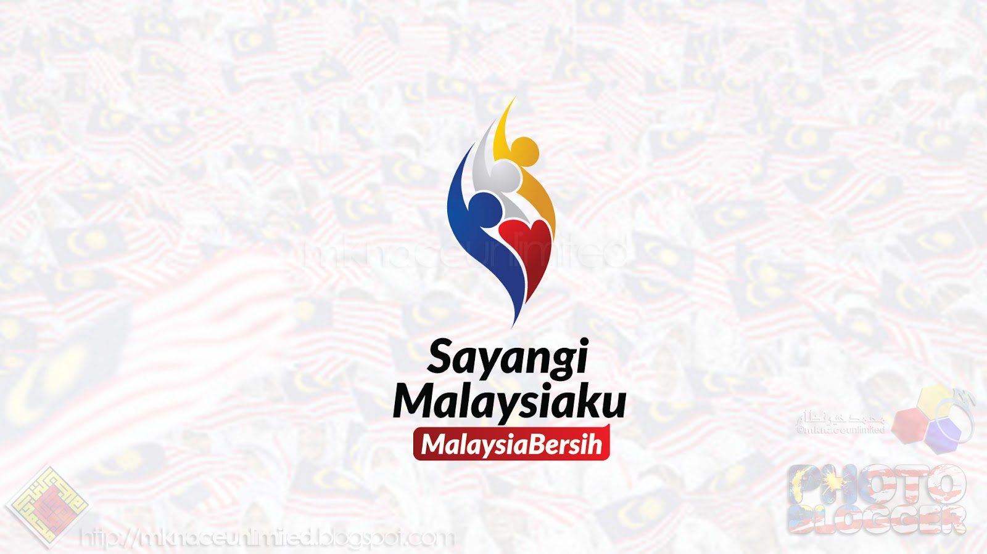
“Sayangi Malaysiaku” menekankan kepentingan perpaduan dan semangat cintakan negara bagi memastikan kesejahteraan dan kemakmuran negara tanpa mengira perbezaan kaum, agama, bangsa dan fahaman.
Source: Ministry of Communications and Multimedia Malaysia
Dear KJB Members
The Chairman and the Members Board of Management of KJB wishes all KJB members Selamat Hari Merdeka on 31st August 2019 and Selamat Hari Malaysia on 16th September 2019. In accordance to the official theme “Sayangi Malaysiaku: Malaysia Bersih” (Love Our Malaysia: A Clean Malaysia) let us celebrate these occasion by strengthening our commitments to the importance of unity, patriotism and shared prosperity for the well-being of all Malaysians.

